
Safeguarding, photograph and GDPR policies

Safeguarding Policy
Purpose:
The purpose of this safeguarding policy is:
• to protect the children and young people who receive tutoring services from Flourish Education from harm.
• to respond to any allegations and / or any concerns relating to the welfare of a child or young adult for those being tutored.
• to state the ongoing training Flourish Education will undertake to ensure that safeguarding protocols are up-to-date and understood by all. This policy applies to anyone working on behalf of Flourish Education.
This policy will be reviewed and updated on an annual basis, or before if there is a change in safeguarding protocols

Responsibilities:
Flourish Education recognises a responsibility for the safety and wellbeing of students. This responsibility includes:
• Ensuring an up-to-date DBS check
• Ensuring appropriate safeguarding training at least once every two years
• Endeavouring to keep up-to-date with any new information about safeguarding and child protection, and updating this policy accordingly to include any changes
• Reporting safeguarding concerns correctly, to the relevant bodies, following the Local Safeguarding Children Board (LSCB) procedures. The Local Authority Safeguarding Lead for the appropriate county will be contacted.
Reporting safeguarding concerns
The following process will be adhered to if (a) a child tells me that they are being abused or (b) I suspect that there are safeguarding concerns for a child who I tutor.
For example: If a student tells me that they or another child is being abused I will: • show that I have heard what they are saying, and that I take their allegations seriously.
• Encourage the child to talk, without prompting them or asking them leading questions. I will not interrupt when a child is recalling significant events and will not make a child repeat their account.
• Reassure the child that they can tell me anything that is worrying them, but that I cannot promise not to tell anybody because some things have to be passed on in order to keep them safe.
• Explain what actions I must take, in a way that is appropriate to the age and understanding of the child.
• Record what I have been told, as soon as I can, using exact words where possible.
• Make a note of the date, time, place and people who were present during the disclosure.
I will contact the Safeguarding Lead for the relevant Local Authority. If I am concerned that the child is in immediate danger, I will call the police. It is not my responsibility to attempt to investigate the situation myself.

Training:
The NSPCC Learning ‘Child Protection for Tutors’ course will be completed. Last completed 02/04/2022. Certificate available – please request.
Safeguarding training should take place at least every two years.

Useful contacts:
Shropshire Safeguarding Partnership (SSP) (safeguardingshropshireschildren.org.uk)
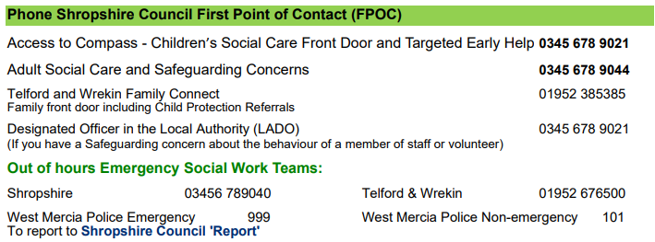
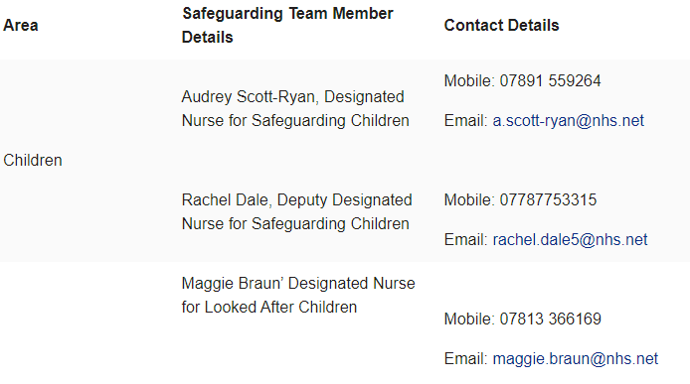

Photograph Policy Flourish Education requires parents and carers to consent to photographs of your child being taken during the registration purpose. If parents and carers consent to this, they are also able to choose from a variety of situations when this is agreeable. This includes for use within electronic journals (individual and group), displays within the setting and on Flourish Education’s social media. Where permission is not provided, photographs will not be taken, or your child will be edited out of the picture.

Photographs of children will only be taken on devices that are registered with Flourish Education.

*** I do/do not give permission for photographs to be taken of my child during tutoring sessions.***
I consent to the following use:
Social Media
Electronic journals
Displays at Flourish Education
Website

Setting Representative: Lisa Savill
Parent’s name:
Parent’s Signature:
Date signed:
Date policy written: 30/08/2022

GDPR Policy
GDPR is important to tutors, because it has regulations and implications on how tutors, as professionals, handle the information they receive about a student and their family, the personal information they collect about a student and their family, and the communication they have with a student or their family.

It is your responsibility to update Flourish Education with any changes in details.

Data held by Flourish Education may include:
• contact details of students and their parents or carers including emergency contact • emails • text messages or other messages via messenger apps • assessments • exam marks • registration forms • correspondence from the students’ school •payment details for sessions.

Storing information:
•Data will only be stored on password protected electrical items relating to Flourish Education.
•Written data is stored in a file per child and only accessed by Flourish Education.
• Information that can be deleted when a child finishes his or her tutoring sessions, on the request of a parent of carer are: SMS or other messages and contact numbers stored on a mobile phone or personal device.
•Information that must be kept for an extended period: • Anything relating to safeguarding, accidents or incidents must by law be held until the child reaches 21 years and three months of age. • Contracts, consent forms, information sheets, invoices and payment information must be held for seven years.

Sharing data:
Information will only be shared with third parties only in the case of a safeguarding issue or if the child’s parent or carer has given permission or specifically asked that information is shared (e.g. with a school).

We are registered with the ICU Commissioner’s Office under the registration number: C1177658.

How to complain:
Please contact us if you have any queries or concerns about our use of your information. We hope we will be able to resolve any issues you may have.
You also have the right to lodge a complaint with the Information Commissioner in the UK.
The UK’s Information Commissioner may be contacted at https://ico.org.uk/make-a-complaint or by telephone: 0303 123 1113.

Setting Representative: Lisa Savill
Parent’s name:
Parent’s Signature:
Date signed:
Date policy written: 30/08/2022

